Copy data from your Homework into StatCrunch

Click the small icon on the data window in your homework and select “copy table to clipboard”

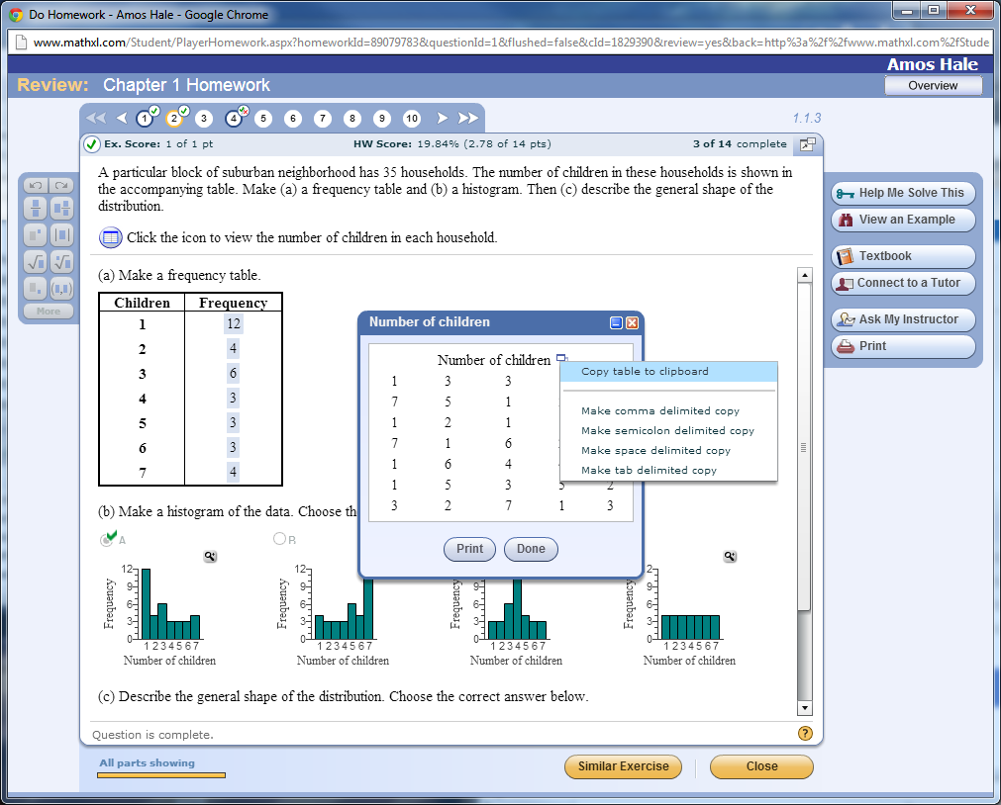

In StatCrunch, click “Edit” and then “Paste”

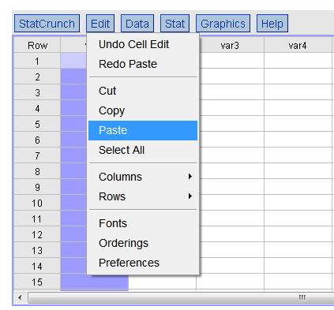

Finally, hit the backspace key to delete the top cell which is the title of the table you copied.

